- Product Specification Sheet -

5.0 mil Nitrile Exam Powder-free Gloves


.


!1



PRODUCT INFORMATION

GLOVE CHARACTERISTICS

- Ambidextrous

- Non-sterile

- Powder-free

- Beaded cuff

SURFACE TREATMENT

- Polymer-coated

- Fully-textured

COLOR

Blue, Black

AVAILABLE SIZES

X-small, Small, Medium, Large, X-large, XX-large

LABELING ON DISPENSER

- Product name

- Size & Quantity

- Lot no.

- Manufacturer’s address

LABELING ON CARTON

- Product name

- Size & Quantity

- Lot no.

- Country of origin

MATERIAL

Nitrile

TOTAL RESIDUE CONTENT

< 2 milligrams per glove

AUDIT STANDARDS

ISO 13485:2003 & ISO 9001:2008

QUALITY CONTROL

Compliant with 510(k); ASTM D 5151; ASTM D 3767; EN 455-1/2/3; EN 420:2003 + A1:2009; FDA 21 CFR 177:2600 (e) & (f) and Overall Global Migration 10/2011

PACKAGING

100 ±1 gloves per dispenser box,

10 boxes per carton,

1000 gloves per carton

STORAGE

Keep away from direct sunlight

& store in a cool, dry place.

!2



PHYSICAL SPECIFICATIONS

COMPLIANT WITH ASTM D 3767, EN 420:2003 + A1:2003 AND ISO 11193
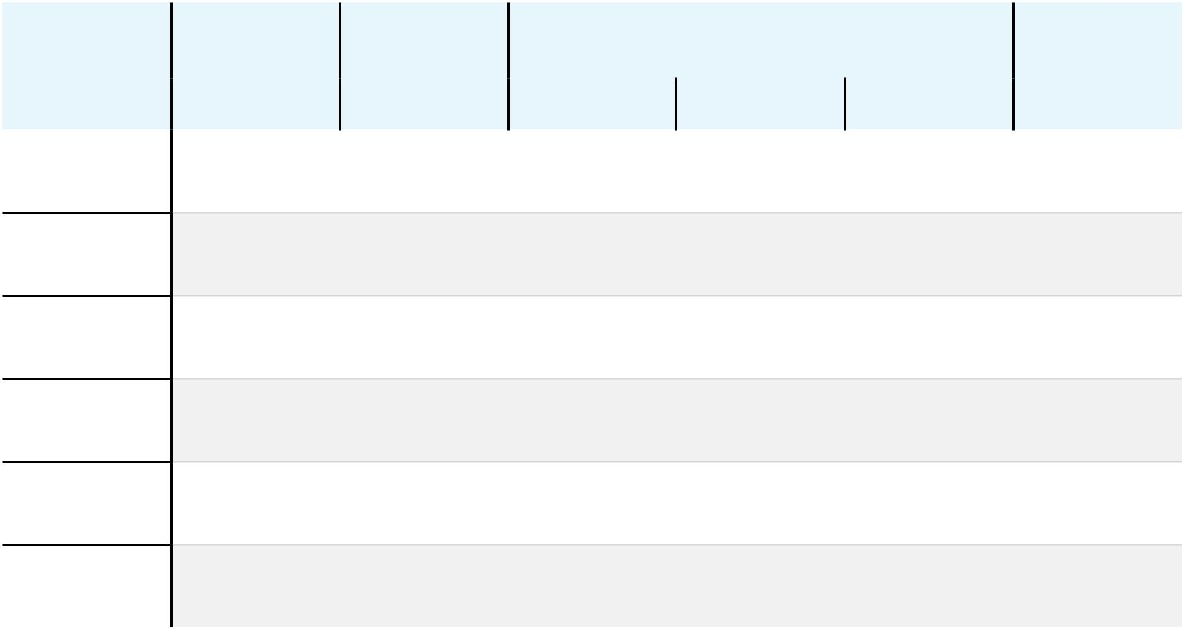

 |  | LENGTH |  | MINIMUM THICKNESS - SINGLE WALL
SIZE |  | LENGTH | WEIGHT (G) |  | (MM) |  | WIDTH (MM)
 |  | (MM)
 |  | (MM) |  | CUFF | PALM | TIP
X-small |  | 240 ±5 | - | 0.09 ±0.01 | 0.11 ±0.01 | 0.14 ±0.01 | 75 ±5
51⁄2 | - 6
Small |  | 240 ±5 | 5.20 ±0.10 | 0.09 ±0.01 | 0.11 ±0.01 | 0.14 ±0.01 | 85 ±5
61⁄2 | - 7
Medium |  | 240 ±5 | 5.40 ±0.10 | 0.09 ±0.01 | 0.11 ±0.01 | 0.14 ±0.01 | 95 ±5
71⁄2 | - 8
Large |  | 240 ±5 | 6.20 ±0.10 | 0.09 ±0.01 | 0.11 ±0.01 | 0.14 ±0.01 | 105 ±5
81⁄2 | - 9
X-large |  | 240 ±5 | 6.50 ±0.10 | 0.09 ±0.01 | 0.11 ±0.01 | 0.14 ±0.01 | 115 ±5
91⁄2 - 10
XX-large |  | 240 ±5 | 6.80 ±0.10 | 0.09 ±0.01 | 0.11 ±0.01 | 0.14 ±0.01 | 120 ±3
101⁄2 | - 11

PHYSICAL PROPERTIES


BEFORE AGING |  | AFTER ACCELERATED AGING |  | FORCE AT BREAK
(ASTM D412-06A) |  | (ASTM D412-06A) |  | (EN 455-2)
Tensile Strength | Ultimate Elongation | Tensile Strength | Ultimate Elongation | > 6 N
> 18 Mpa | > 500% | > 18 Mpa | > 400% | > 6 N

!3

